**Cheetos Management System**



Session: 2022 – 2025

**Submitted by:**

M. Taha Shahid 2022-CS-197

**Supervised by:**

Dr. Awais Hassan

Department of Computer Science

**University of Engineering and Technology**

Contents

**SHORT DESCRIPTION:** 4

**1.** **AIM** 4

**2.** **DISTRIBUTION AMONG SECTIONS** 4

**3.** **SIMULTANEOUS IMPORTING AND EXPORTING** 4

**USERS OF APPLICATION:** 4

**FUNCTIONAL REQUIREMENTS** 4

**1.** **ADMIN** 4

• **CREATE** 4

• **RETRIEVE** 5

• **UPDATE** 5

• **DELETE** 5

• **SORTING** 5

• **RECOMMENDATIONS** 5

• **VALIDATION** 5

• **REFUND** 6

• **INFORMING EMPLOYEES** 6

• **INFORMING SECTION LEADERS** 6

**2.** **EMPLOYEES** 6

• **CREATE** 6

• **RETRIEVE** 6

• **UPDATE** 6

• **DELETE** 7

• **RECOMMENDATIONS** 7

• **VALIDATION** 7

• **AVOID INGREDIENT WASTAGE** 7

• **SUGGESTIONS** 7

• **VIEW DEADLINES** 7

• **EDIT INGREDIENT ORDERING** 8

**TABLE** 9

**1.** **Admin** 9

**2.** **Employee** 11

**WIREFRAMES** 13

***Figure 1: Sign in page*** 13

***Figure 2: Admin's menu*** 14

***Figure 3: Adding user to the system*** 15

***Figure 4: Admin viewing and sorting orders*** 15

***Figure 5: Employer's screen*** 16

***Figure 6: Employee viewing his requests*** 16

***Figure 7: Admin sending a message to an employee*** 17

***Figure 8: Employee writing up a suggestion*** 17

# **SHORT DESCRIPTION:**

## **AIM**

This project aims at designing a management system for a Cheetos making factory. The project aims to keep track of all the ingredients needed to make different Cheetos flavors in different quantities. The standard quantities that the factory is expected to manufacture might change, should the company obtain any new equipment to facilitate manufacturing or for any other reasons.

## **DISTRIBUTION AMONG SECTIONS**

After that, the ingredients will be distributed among different sections inside the factory, with each section responsible for a specific flavor. In case of shortage of ingredients due to unknown external factors, the program will be able to prioritize which sections should gain more ingredients based on which flavors of Cheetos are in more demand by the customers. Or it might equally distribute the short amount of ingredients among sections and manufacture a small amount of Cheetos for all flavors. The program will decide on an approach that will guarantee the company most profit and the least wastage of ingredients.

## **SIMULTANEOUS IMPORTING AND EXPORTING**

After the manufacturing process is done, the Cheetos will be sent to different shops and stores while simultaneously, another order of ingredients will be passed on to the suppliers. So that as soon as the finished products leave the factory, the next batch of ingredients will also have arrived for preparing the next batch of products.

# **USERS OF APPLICATION:**

* Admin
* Employees

# **FUNCTIONAL REQUIREMENTS**

## **ADMIN**

### **CREATE**

The admin will be able to create any ingredient order or manufacturing order**.**

### **RETRIEVE**

The admin will also be able to retrieve specific orders for detail viewing.

### **UPDATE**

In case of any external unknown factors that might affect the quantity of ingredients coming to the factory, or the amount of manufactured products, the admin will be able to implement updated orders, according to latest calculations.

### **DELETE**

In case of cancellation by stores, the admin can delete those orders from the system. The system will then automatically be open to place another order in place of the deleted order.

### **SORTING**

The system will sort data according to two formats. The admin will have to choose the format he wishes to implement. Either the system will show orders in a way that the orders which need to be completed on the most urgent basis are shown at the top. Or it can arrange them according to feedback obtained from stores and shops, and show those orders first which have a greater demand than other orders.

### **RECOMMENDATIONS**

The system will automatically calculate the amount of ingredients needed to fulfil a certain number of orders, and suggest these amounts to admin and employees. It will suggest shops which products should they order, and also suggest which manufacturing orders need to be completed first, based on the prioritization standards that the employees and admin would have set in the first place.

### **VALIDATION**

Admin can validate that the ingredients used do not exceed ingredients available at a certain time or that the factory does not accept orders for products that they do not manufacture. He can also validate that the amounts of ingredients received do not exceed the amounts in which they were ordered.

### **REFUND**

The received amounts can be less than the ordered amounts for some unknown reasons. In that case, the admin can view by what extent were the ingredients less than the ordered amounts. The admin can then use the application to demand for a refund for the ingredients not delivered or cancel out that refund from the next batch order.

### **INFORMING EMPLOYEES**

In case of cancellation of orders, the admin will also be able to inform everyone of an order that was deleted through the application. Through this approach, wastage of time and ingredients on fulfilment of a cancelled order can be avoided. Similarly, the factory can cancel/delete its own orders for ingredients.

### **INFORMING SECTION LEADERS**

Section leaders are employees which have been promoted to the position to manage sections of the factory which are responsible for specific flavor of Cheetos, as explained previously. If an order is updated after the initial distribution of ingredients, the admin will be able to guide the section leaders on how to exchange ingredients among themselves or where to receive additional ingredients to fulfill the updated orders.

## **EMPLOYEES**

### **CREATE**

An employee will be able to create an ingredient order request for the admin and section leader to review**.**

### **RETRIEVE**

An employee will also be able to retrieve his request to view its status.

### **UPDATE**

Employees can update their requests to accommodate any extra changes before the request gets reviewed by the admin. After the request has been reviewed by the admin though, the request can no longer be edited, and a new request must be published for any new changes.

### **DELETE**

Employees can also delete their requests before they are reviewed by the admin. This saves time for the admin as he no longer has to review the requests that the employee himself has deemed no longer necessary.

### **RECOMMENDATIONS**

In case a section has found some ingredients to be in excess quantities, they can log those excess amounts into the system. Resultantly, if any other section is in shortage of some ingredients, the system can recommend the excess ingredients to the sections in need. This saves time and resources for the factory.

### **VALIDATION**

Section leaders can validate that the ingredients received by their particular section does not exceed the amounts required for the manufacturing of their particular flavor. If the amount received exceeds the amount needed, the section leader can log the excess amount into the system as explained before.

### **AVOID INGREDIENT WASTAGE**

If the excess amounts that were logged onto the system are not used by other sections, they will be used in the next batch order and this excess amount will be subtracted from the next batch order to save money and ingredients wastage.

### **SUGGESTIONS**

Employees are encouraged to provide any suggestions for the improvement of eh system. Their suggestions will be saved in the system for further review.

### **VIEW DEADLINES**

The employees will be able to view the deadlines for delivering their manufactured products. In case of delayed deadlines due to external factors, the employees can use the system to request a delay in the deadline. The request will be reviewed by the section leader, and then the admin. The section leader will also be able to log the cause of the delay into the system, so that the admin can ensure that such delays do not occur in the future.

### **EDIT INGREDIENT ORDERING**

The employees can also edit the amounts of ingredients that need to be ordered for the next batch of manufacturing, but such requests much first be reviewed by the section leaders and admin. If employees start following a new recipe with different quantity usage of ingredients, without logging their changes to the system, this can cause wastage/shortage of ingredients.

## **TABLE**

### **Admin**

|  |  |  |  |
| --- | --- | --- | --- |
| No. of feature | *As a* | *I want to perform* | *So that I can* |
| **1** | Admin | Manually create ingredients or manufacturing orders. | Ensure that the system does not fail due to external factors that the program automatically fails to take into account. |
| **2** | Admin | View manufacturing and ingredients orders | Keep track of ingredient wastage/shortage and calculate profit/loss margins. |
| **3** | Admin | Update an existing order. | Meet the latest needs of the factory |
| **4** | Admin | Delete an order | Save time, money and resources by cancelling an order that has become unnecessary before it is fulfilled |
| **5** | Admin | Sort my orders | To be able to prioritize orders based on their received feedbacks or deadlines. |
| **6** | Admin | Receive recommendations from the system regarding the amounts of ingredients needed to be ordered | Avoid manually calculating amounts of ingredients needed to be ordered for every batch |
| **7** | Admin | Validate orders | Ensure that the system does not start a project that will eventually result in failure, as that will consume a lot of time for the factory. |
| **8** | Admin | Ask refund for excess ingredients before ordering the next batch | To avoid wastage of ingredients and money by using the excess ingredients of a previous batch in the next batch order |
| **9** | Admin | Quickly inform employees of a cancelled order | So that the employees do not waste time fulfilling cancelled orders. |
| **10** | Admin | Inform section leaders how to manage shortage/excess of ingredients among themselves. | To avoid ordering more ingredients to replenish a shortage that could have been handled inside the factory. |

### **Employee**

|  |  |  |  |
| --- | --- | --- | --- |
| No. of feature | *As an* | *I want to perform* | *So that I can* |
| **1** | Employee | Create ingredients orders request. | Find the ingredients during manufacturing that I feel are needed |
| **2** | Employee | View the status of my request | Know whether my requests are approved or not, rather than being in a state of uncertainty. |
| **3** | Employee | Update my request before reviewed. | Accommodate extra changes in a single request to save my and admin’s time |
| **4** | Employee | Delete a request. | Save everyone’s time by avoiding the reviewing of a request that I, myself, feel no longer to be valid. |
| **5** | Employee | Log excess/shortage of ingredients to the system | Send/receive recommendations for exchange of ingredients between sections. |
| **6** | Employee | Validate my orders with respect to their quantities | Avoid complications of excess/shortage of ingredients. |
| **7** | Employee | View excess ingredients | See if I can replenish any shortage of ingredients through batch order from excess ingredients from the previous batch |
| **8** | Employee | Offer suggestions and view their status | To improve the factory performance in a way that is beneficial for me and fellow employees. |
| **9** | Employee | View deadlines and request delays if necessary | Keep up with my orders and not repeat mistakes that cause delays in my work |
| **10** | Employee | Edit recipes according to latest feedbacks that might ultimately result in a new flavor | So that when I need to change the quantities of ingredients, I can avoid complications like shortage and excess of ingredients. |

# **WIREFRAMES**

First of all, a login screen will be presented. After the user logs in, the system will determine whether the user is an admin, an employee, or a buyer. The sign up option is not presented because not anyone can just sign up for a private system. Only admins can add users to the system and assign ther usernames to the employees manually in order for them to use the system.

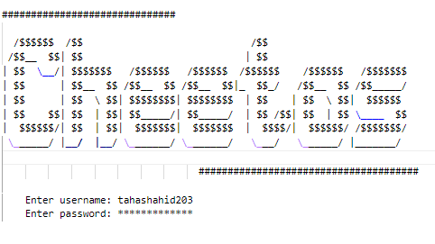

**Figure 1: Sign in page**

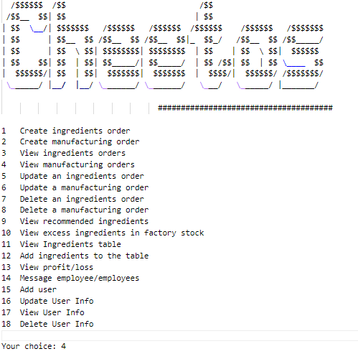

### ***Figure 2: Admin's menu***

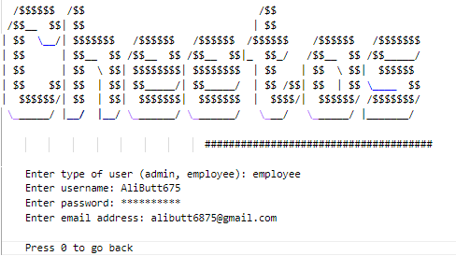

### ***Figure 3: Adding user to the system***

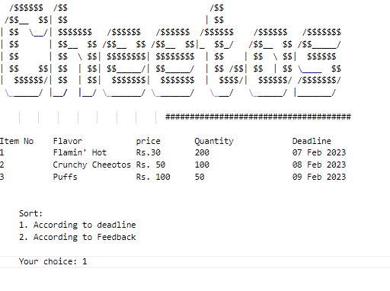

***Figure 4: Admin viewing and sorting orders***

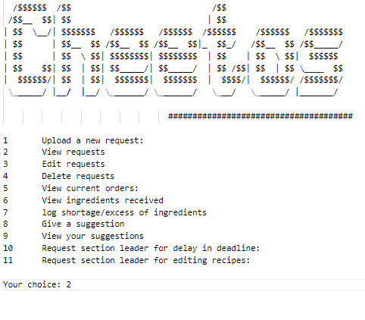

### ***Figure 5: Employer's screen***

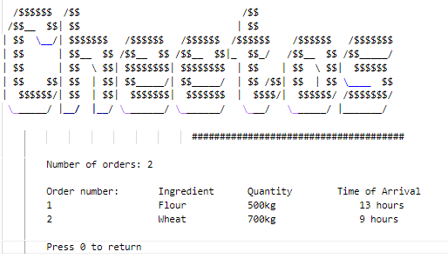

***Figure 6: Employee viewing his requests***

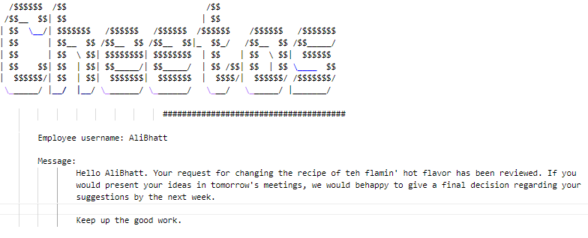

### ***Figure 7: Admin sending a message to an employee***

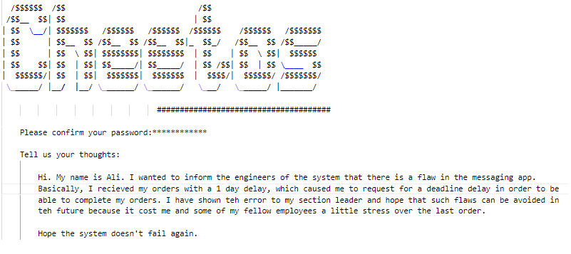

### ***Figure 8: Employee writing up a suggestion***